**Tableau Worksheet Exercise**

Please use the screenshots ONLY as a reference. The written instructions have to be followed AS written.

PLEASE MAKE SURE YOU SUBMIT ALL THE SCREENSHOTS WITH TIMESTAMPS AT THE BOTTOM RIGHT (WINDOWS USERS) OR ELSE YOU WILL AUTOMATICALLY QUALIFY FOR A DISCOUNT.

**Objective:**

To understand how to make charts in Tableau by implementing join, aggregation, sort and filter techniques in a worksheet.

**Step 1: Prerequisite**

Before you can begin, your computer needs the Tableau Desktop installed and working.

* Tableau is a business intelligence tool used for data visualization. It turns data into meaningful insights.

Step 2: Installation of Tableau Desktop

1. Click on the link below and select “Get Tableau for free”

<https://www.tableau.com/academic/students>

1. On the form, enter your school email address for Business E-mail and enter the name of your school for Organization.
2. Once Tableau is installed, activate it with the product key listed in the associated document.

**Step 3: Connecting to a Data Source**

1. Launch Tableau from your desktop.
2. Click on “Sample – Superstore” as shown in the screenshot below.

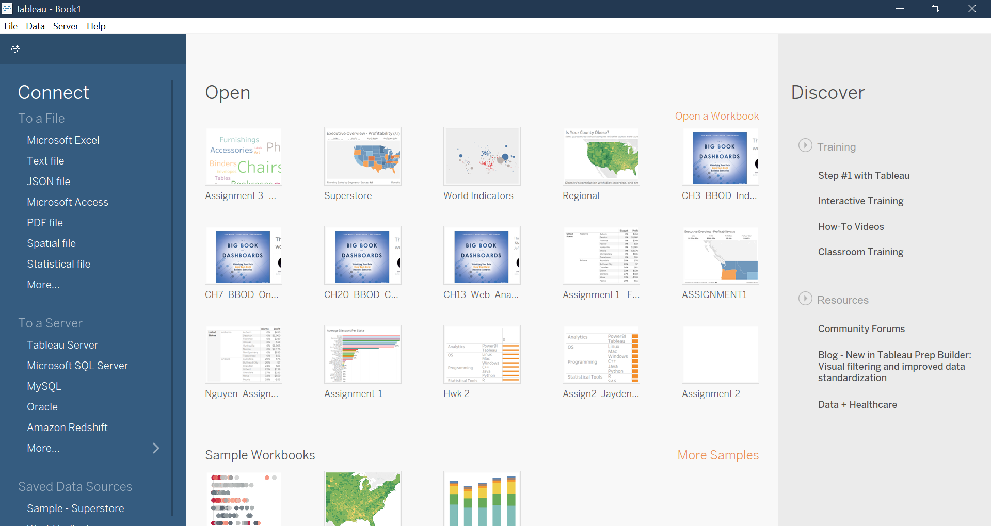

1. Select the Sample – Superstore data set. This is a sample dataset provided by Tableau. The data set includes sales data for a big box Superstore (Walmart, Target, Home Depot).

Step 4: Exploring the Dataset

The resulting screen is called a worksheet. It provides shelves to drag and drop dimensions and measures to construct a visualization.

Dimensions contain qualitative values (such as names, dates, or geographical data). It is used to categorize, segment, and reveal the details in the data.

Measures contain numeric, quantitative values that can be measured. It can be aggregated.

Click on the “Data Source” button at the bottom left part of your screen.

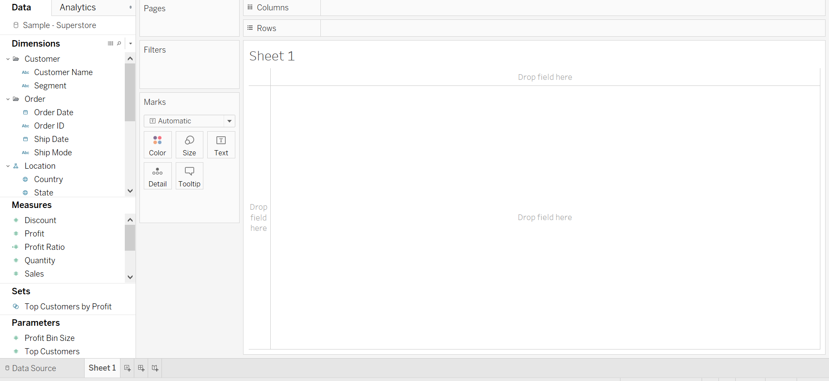

Question 1: Paste the screenshot of the resulting screen.

Click on the “View Data” icon next to the Orders table

Question 2: Total how many tables are there in the loaded dataset? What is the total number of rows in the orders table? What is the total number of columns in the Orders table?

**Step 5: Relationships**

Relationships are an easy, flexible way to combine data from multiple tables for analysis. You define relationships based on matching fields, so that during analysis, Tableau brings in the right data from the right tables at the right aggregation—handling level of detail for you. A data source with relationships acts like a custom data source for every viz, but you only build it once.

Here, the **Orders** table is our fact table because it describes our business process. We want people to order items from our Superstore, and when they do, they are recorded in the Orders table.

The default which the updated version of Tableau implements is a Relationship. Now drag the People table next to the Orders table to create a relationship between the two.

This is where we will define the characteristics of our relationship. Make the following changes by clicking on the line between the two tables and enlarging the Performance Options.

Tableau recognized that there was probably a relationship between the Region field from the Orders table and the Region field in the People table. If this had not been the case, then you would have needed to select the fields from the drop-down that you want to relate.

Next you will need to select the **cardinality** for this relationship. Here, there are many rows with each region in the Orders table but there is only one row per region in the Region table. This means the cardinality is **many-to-one**. Choose those options from the drop-down accordingly.

Similarly, create a relationship between Orders and Returns table by dragging the Returns table on canvas and making the following changes:

Question 3: Paste a screenshot of your relationship between the Orders, the People and the Returns table.

Step 6: Rename Worksheet

Click on the “Sheet 1” icon on the bottom to go back to the worksheet.

Double click or right click on “Sheet 1” and rename it to your “Firstname_Lastname”.



Question 4: Paste a screenshot of the renamed worksheet.

**Step 7: Aggregation**

Drag the Category variable from Dimensions to the Columns shelf.

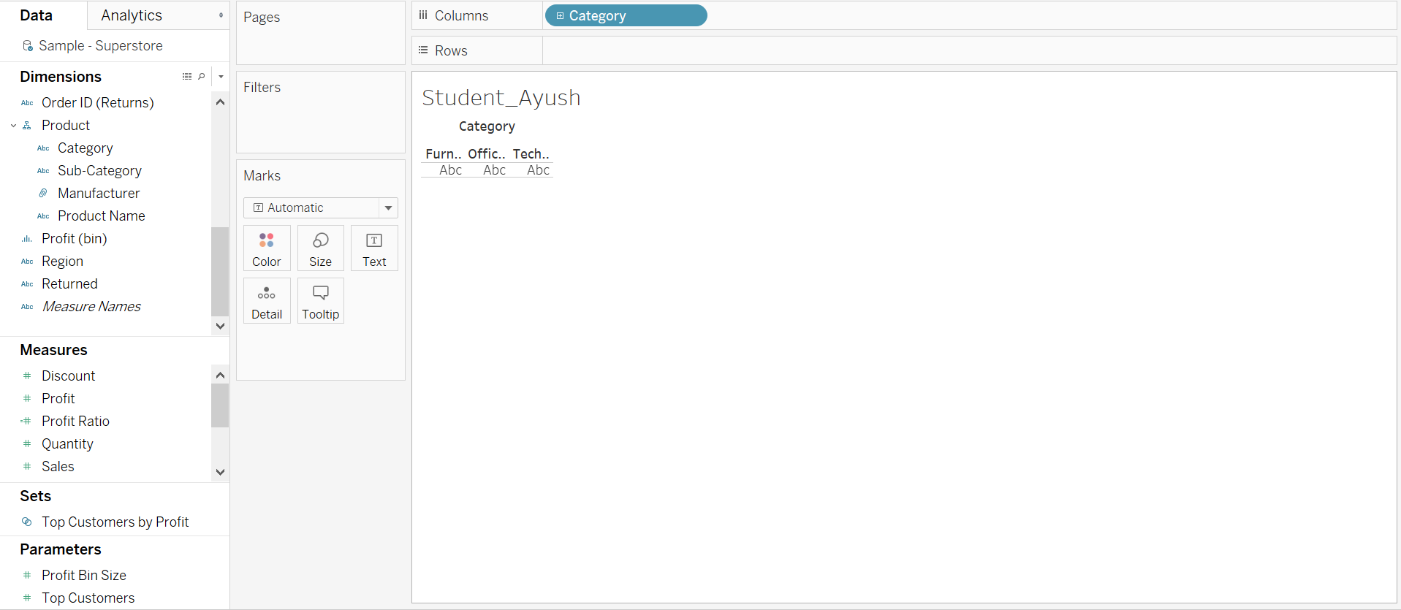

Now drag Profit from Measures to the Rows shelf.

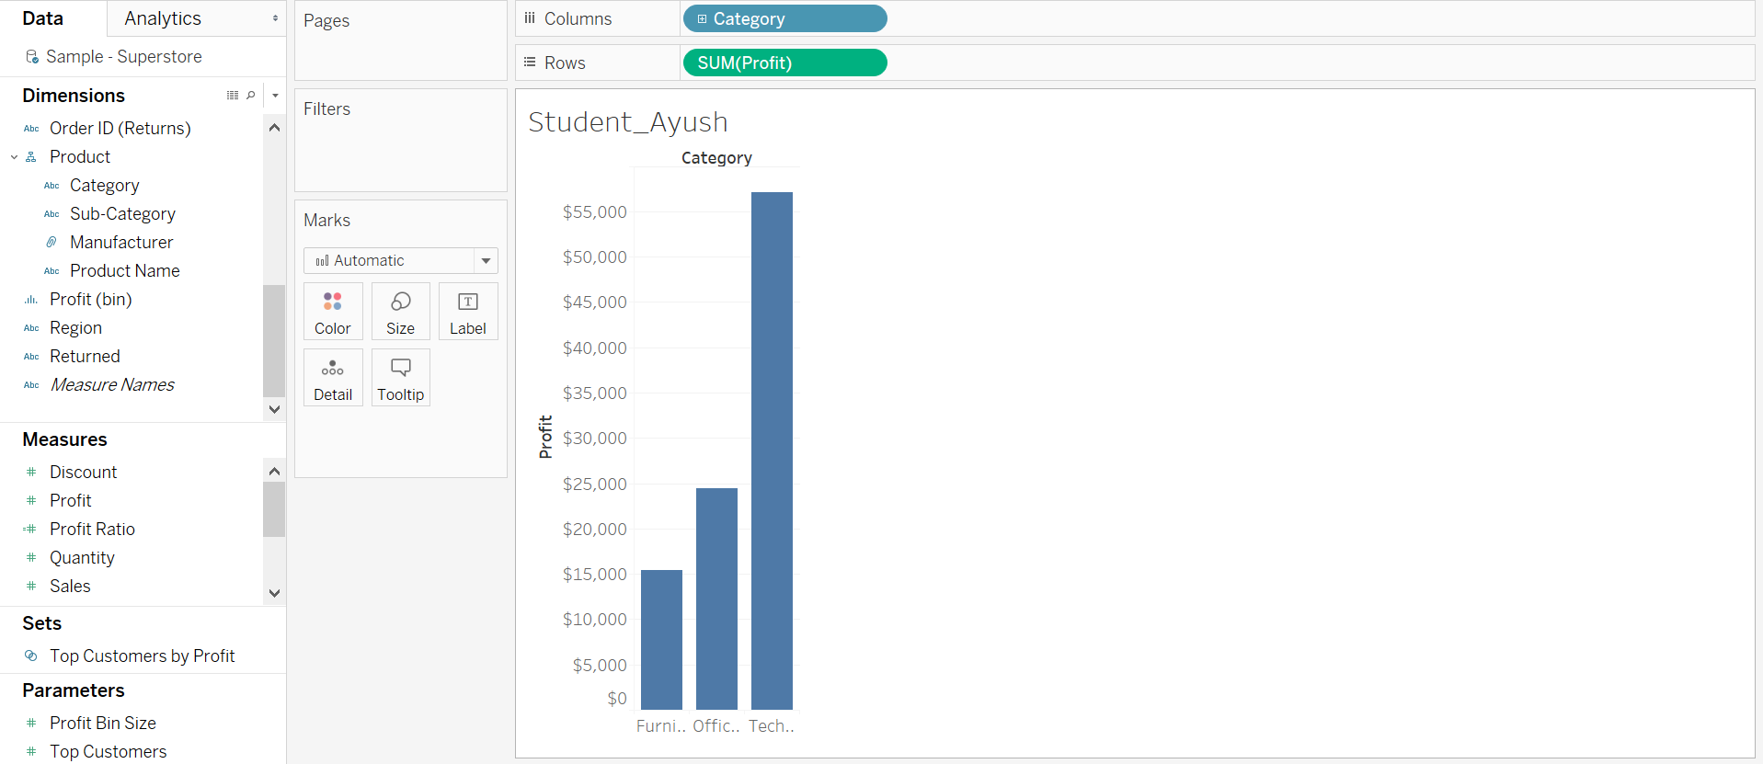

Question 5: What is the default aggregation in Tableau?  
a) Mean  
b) Sum  
c) Median  
d) Count

Hover the mouse over the green pill, click on the small white triangle and select “Average” from the Profit Measure.

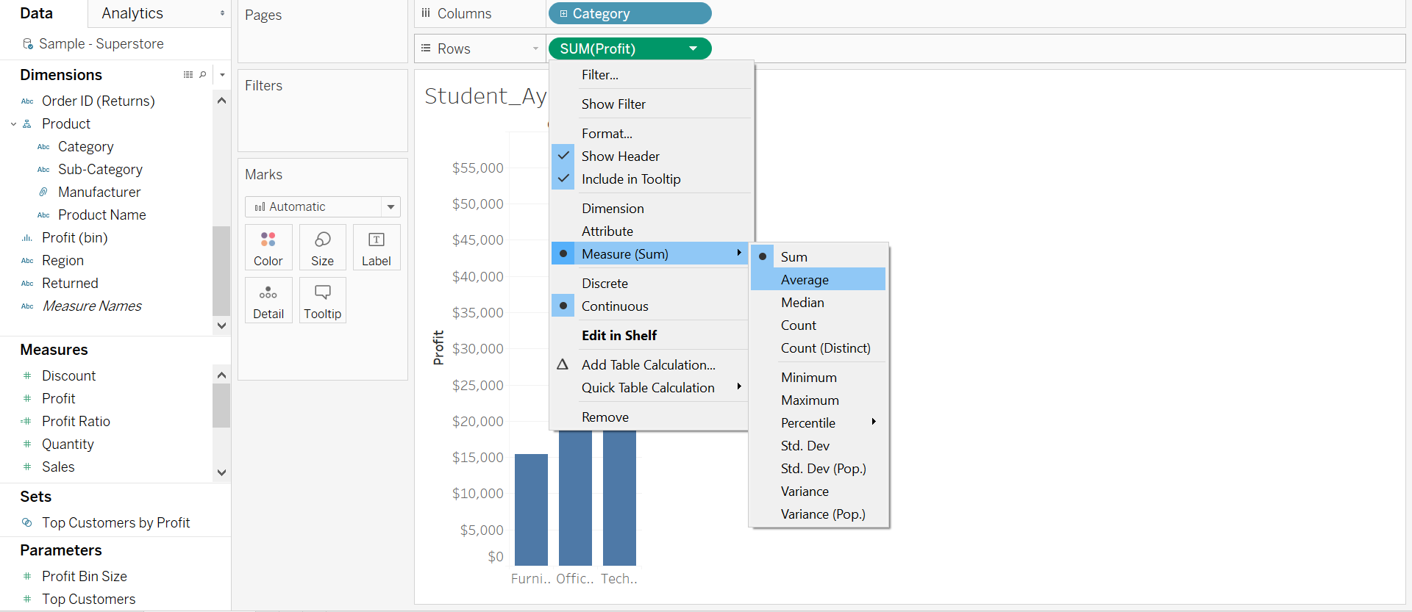

Select “Entire View” as shown in the below screenshot.

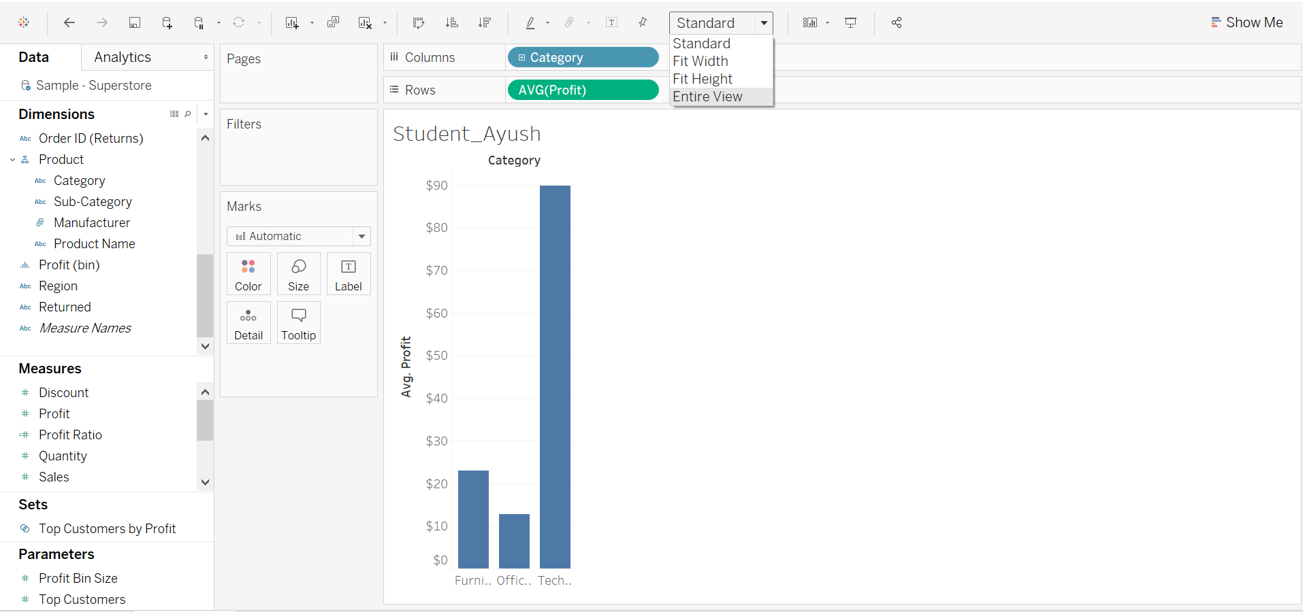

5. Rename the current worksheet to “FirstName - Bar Chart”

Question 6: Paste the screenshot of your screen showing the entire view.

Question 7: What changes were observed in the bar graph when aggregation was changed from sum to average?

**Step 8: Filters**

1. Create a new worksheet by clicking at the bottom worksheet icon. Also, rename the new worksheet as “FirstName – Scatter Plot”



1. Drag the “Profit” measure to the Columns shelf. Drag “Sales” from Measures to the Rows shelf.

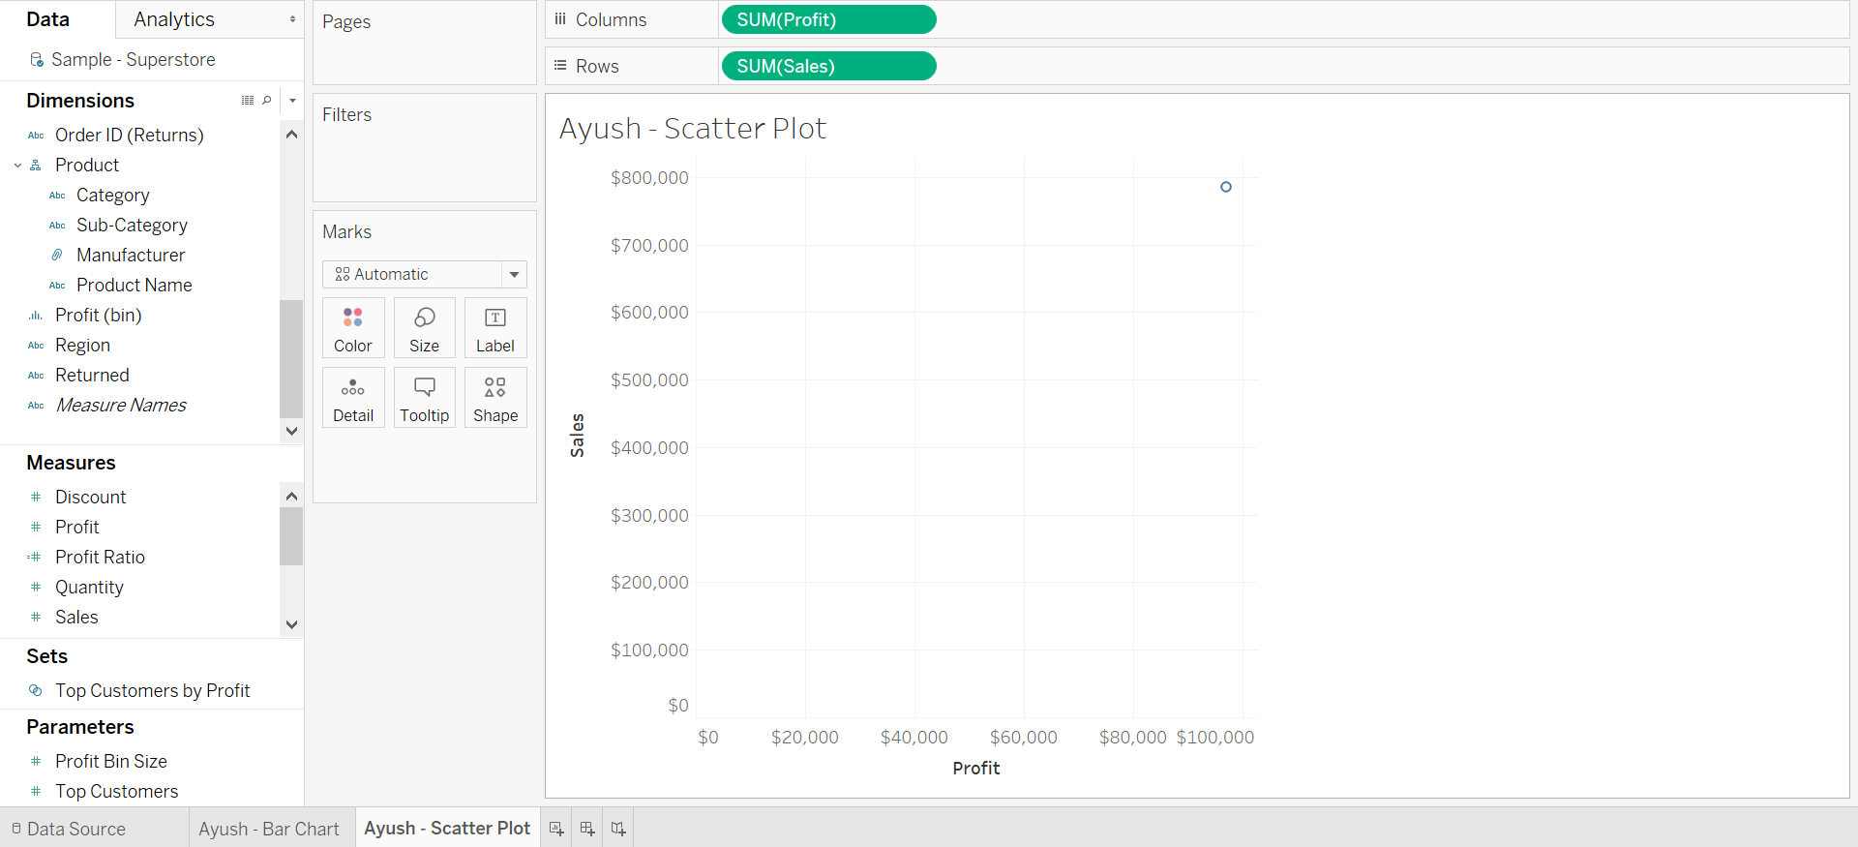

1. Drag “Sub-Category” from Dimensions to color on the marks shelf.

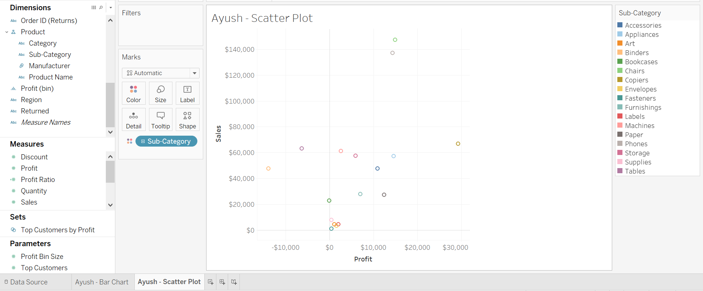

1. Drag “Order Date” from Dimensions to the Filters shelf.

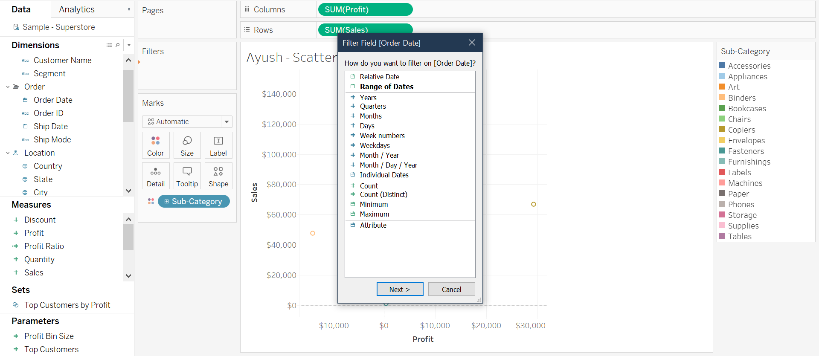

1. Click on “Years”. In the next pop-menu select 2018 through the current year. Finally, click on the apply button then hit Ok.
2. Hover the mouse on the newly created filter, click on the white triangle and select “Show Filter”.

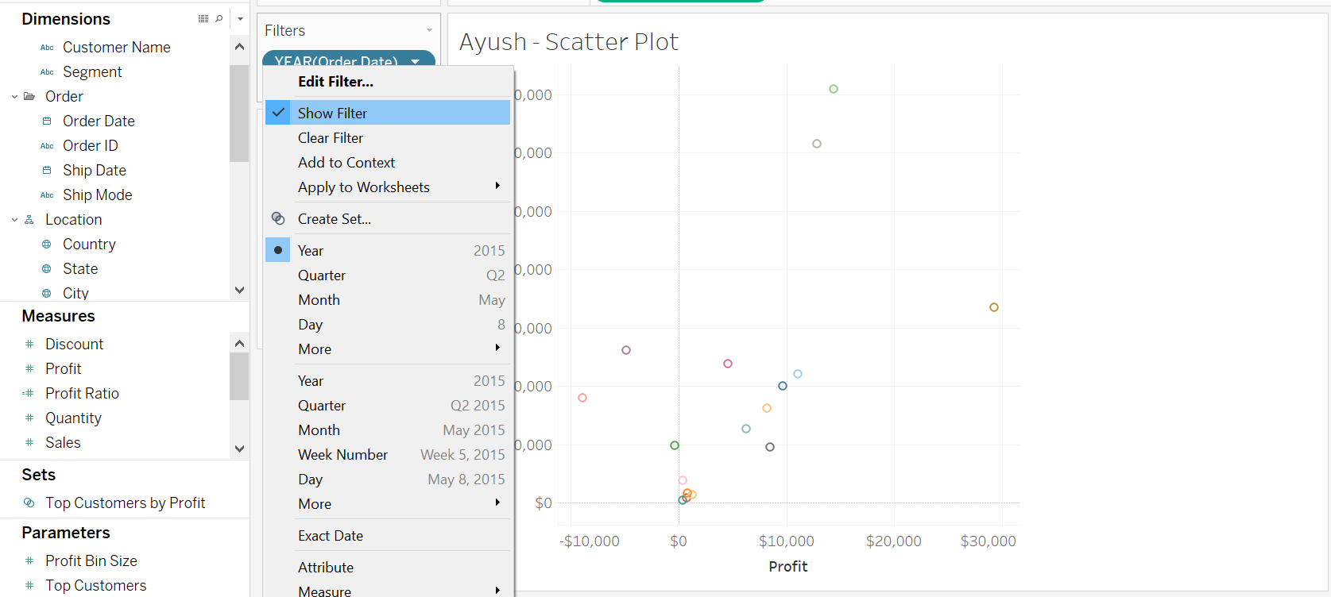

1. Hover mouse over the engaged filter on the right side. Click on small white triangle and de-select “Show All Value” from Customize.

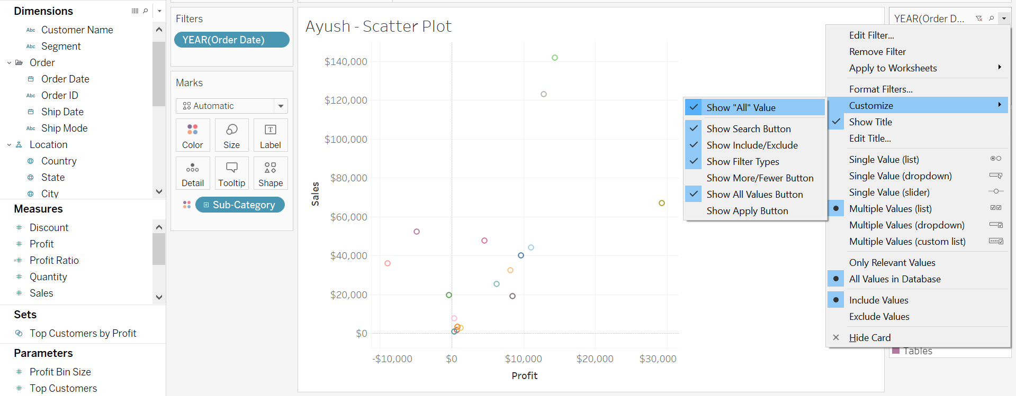

Question 8: Paste the screenshot of your screen showing the “Entire View”

Question 9: Which sub-category has sales greater than $140,000? Which sub-category has Profit greater than $10,000?

Step 9: Histogram

1. Create a new worksheet and rename it to “FirstName – Histogram”.
2. Drag “Quantity” from Measures to the Rows shelf.
3. Click on the “Show Me” tab on top right and select “Histogram”. Notice what happens to the visualization.

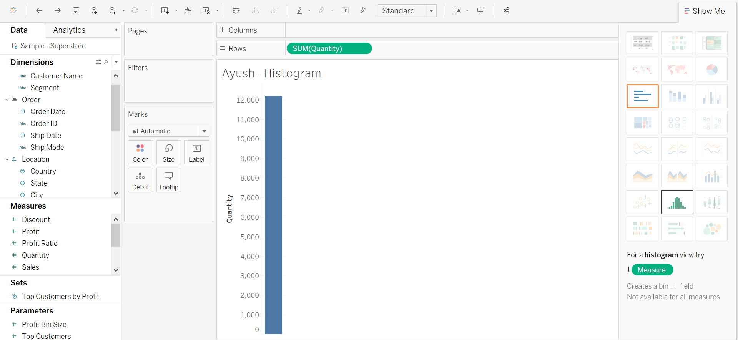

1. Right click on the bottom axis then click on “Edit Axis”.

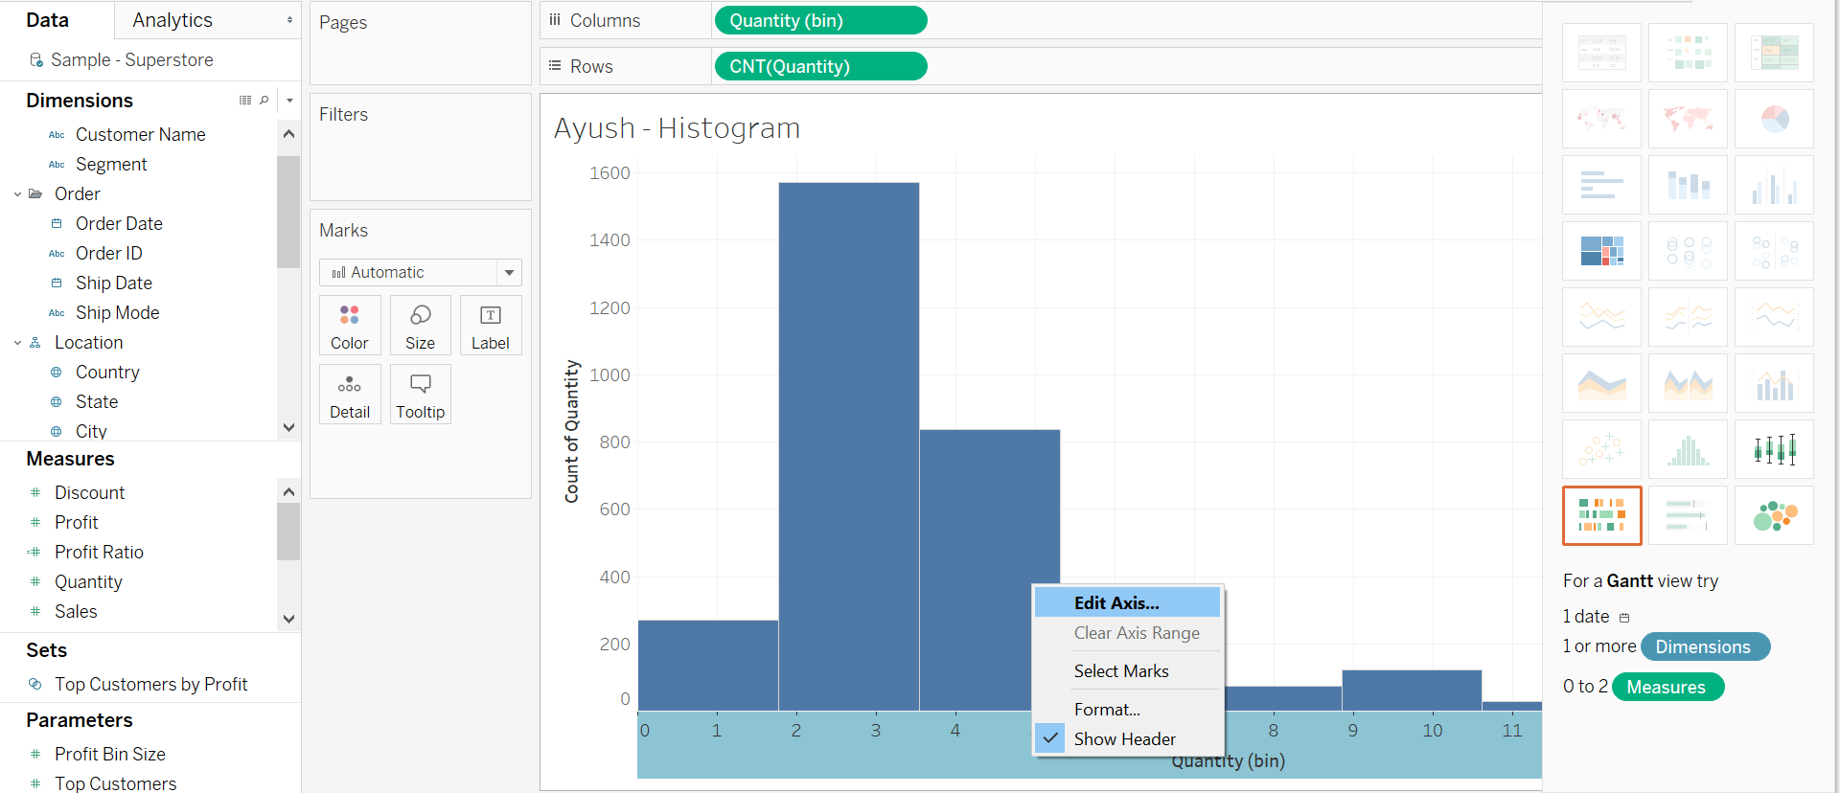

1. In the pop-menu click on the Tick Marks tab and select Fixed and change the major tick interval to the setting “0 to 3”.

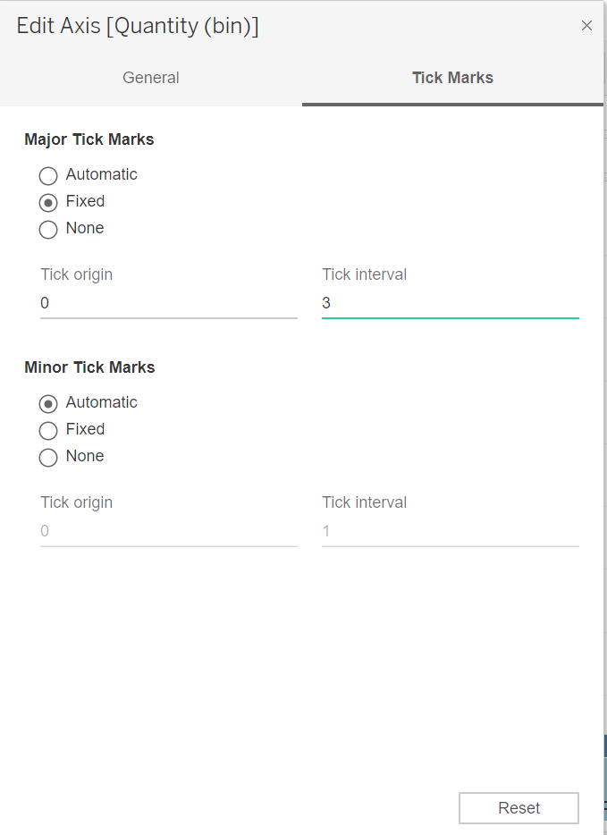

1. Right click on Quantity(bin) in Dimensions, then click on Edit.

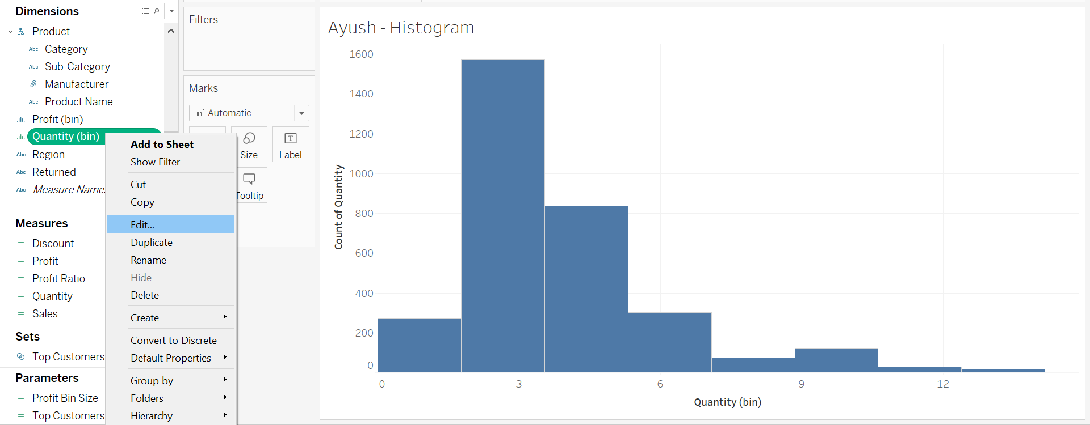

1. In the pop-up menu, set the size of bins to 3, then click on OK.

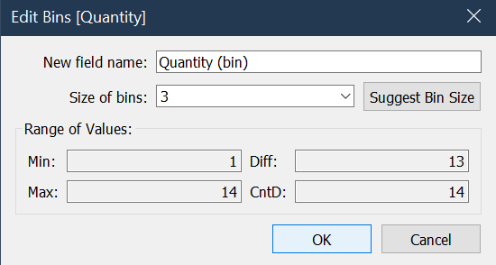

Question 10: Paste the screenshot of your current screen showing the “Entire View”.

Step 10: Highlight Tables

1. Create a new worksheet and rename it to “FirstName – Highlight Tables”.
2. Drag “Category” and “Sub-Category” from Dimensions to the Rows shelf in that order.

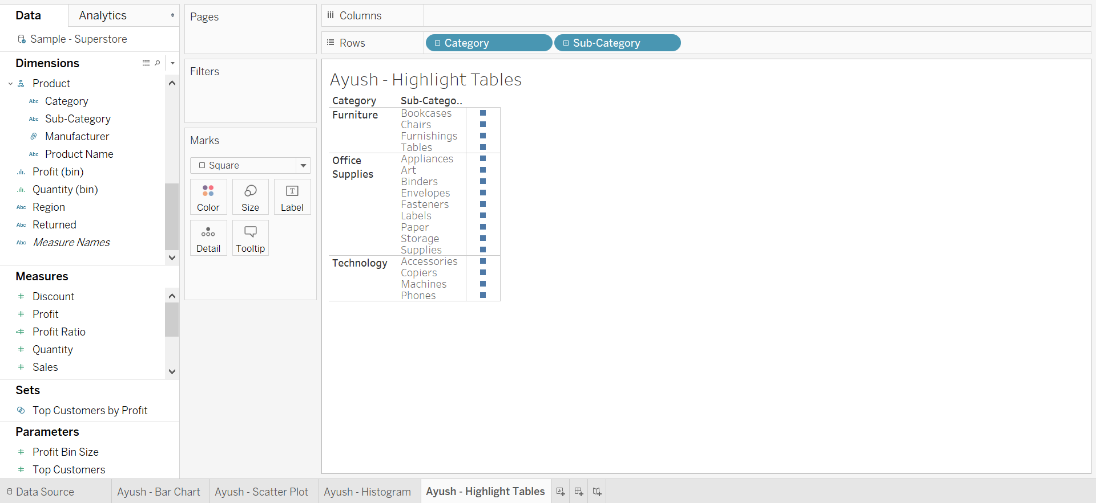

1. Drag “Profit” from Measures to the color mark.

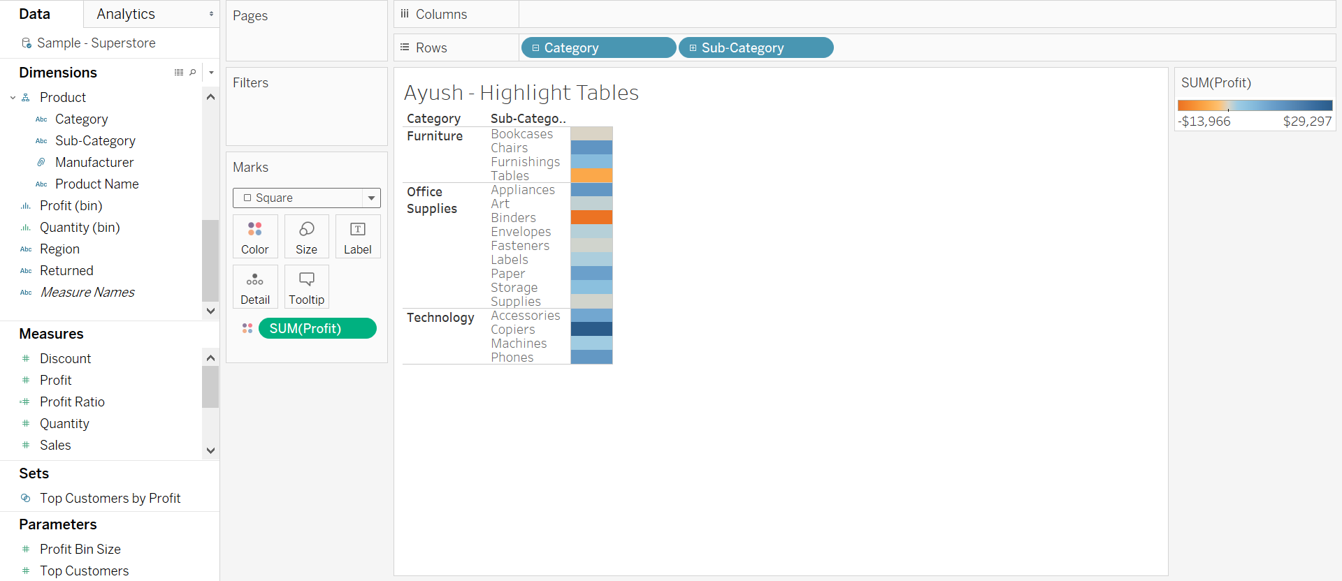

1. Drag “Profit” from Measures to the Label on the Marks shelf.

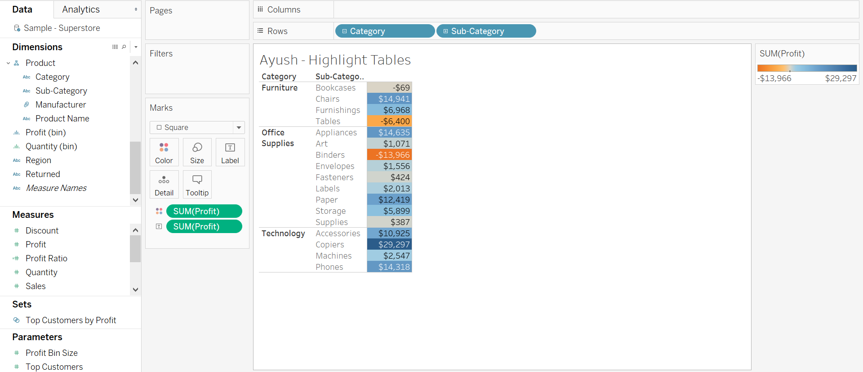

Formating: The format of your table cells and labels may not be what you expected. When you drag SUM(Profit) to the color encoding it changes the cells to the correct color of profit for that cell. Then when we drag the same SUM(Profit) measure to the Text encoding, Tableau says ok you want the text in the cells(and colored). Change the “Marks” card from “Automatic” to “Square”. This means I wantr color squares with text values in them.

Question 11: Paste the screenshot of your screen.

Question 12: Which sub-categories are making the most profit? Which sub-categories are making the least profit? List 3 sub-categories with their corresponding values for each with your answers.

Step 11: Sorting

1. Create a new worksheet and rename it to “FirstName - Sales and Profit”.
2. Drag “Sub-Category” to the columns shelf. Drag “Sales” to the rows shelf.

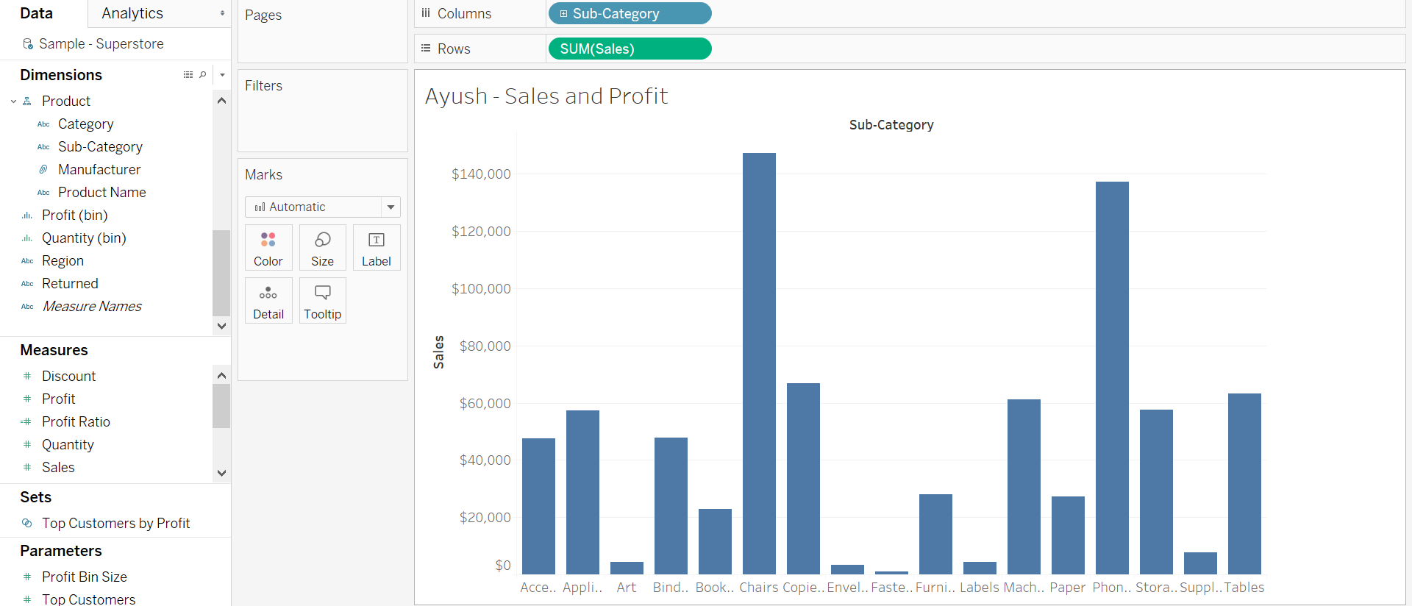

1. Hover your mouse over “Sub-Category” then click on the small white triangle and select Sort.

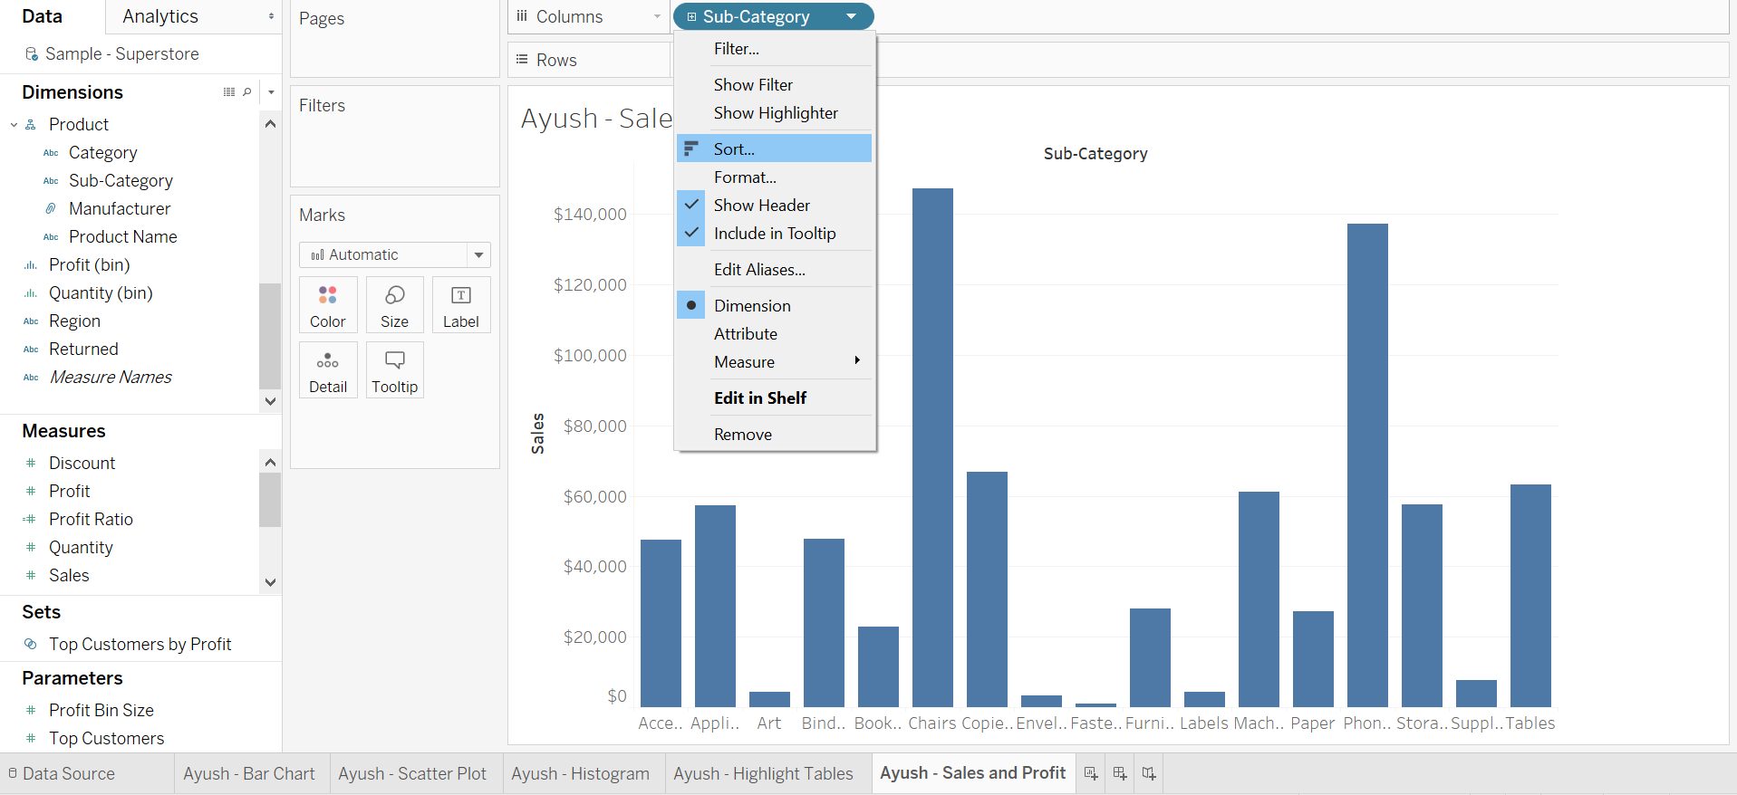

1. Within Sort, select “Field” as the data source order.

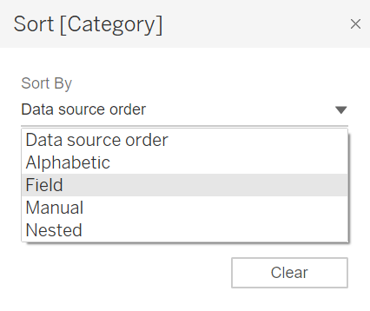

1. Change the sort order to Descending and select Profit for the field name.

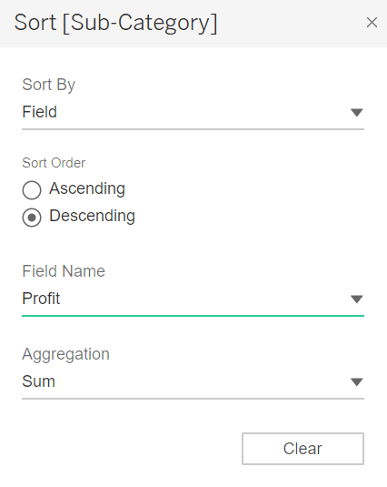

1. Drag “Profit” from Measures to Tooltip in the Marks shelf .

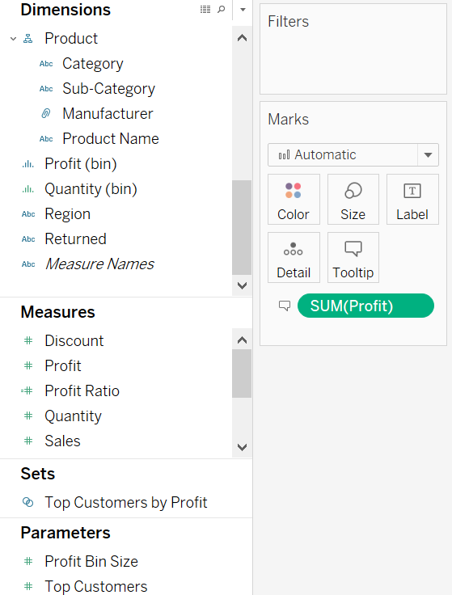

Question 13: Paste the screenshot of your screen showing the “Entire View”.

Question 14: Which sub-categories have the highest sales? Which sub-categories have the highest profits? List 3 sub-categories for each with their respective values.

Hint: Hover mouse over individual bars for profit and sales values.

From the File menu at the top left, save your file as “Firstname_Lastname”. Make sure to save the file as .TWBX. Submissions using any other extension will receive heavy discounting.

**Instructions:**

1. Submit the assignment document in Microsoft Word to eLearning.
2. Submit your TWBX file on eLearning .
3. Include only screenshots and answers with proper question numbers. For any additional step/instruction or improper question numbering your assignment will be discounted.